33.63: a) For the secondary rainbow, we will follow similar steps to Pr. (34-51). The total angular deflection of the ray is:
where we have used the fact from the previous problem that all the internal angles are equal and the two external equals are equal. Also using the Snell’s Law relationship, we have: 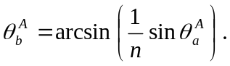
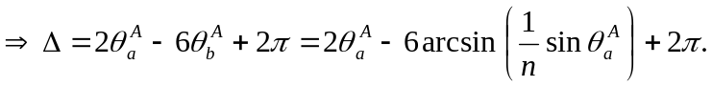
b) 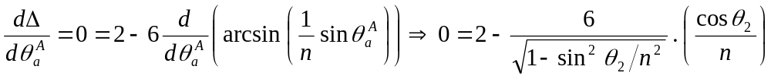

c) For violet: 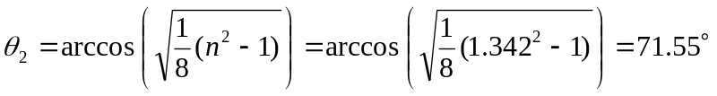
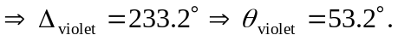
For red: 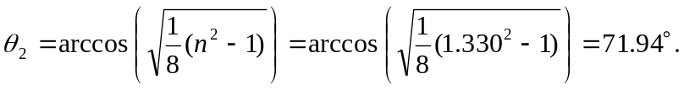
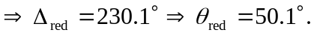
Therefore the color that appears higher is violet.

